On This day, July 11, 1813, The Battle of Black Rock Sparks a Trail of Fire That Leads to the White House!
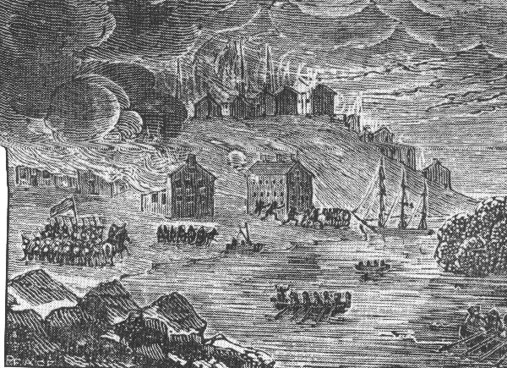

If you "google" Black Rock, NY, the source Wikipedia sends you instead to Buffalo, NY. One thing's for sure though, no other Buffalo suburb can claim the rival forming history of Black Rock and Buffalo. It was almost the other way around, but for the Erie Canal.
At the time of the Battle of Black Rock, the little village was in all her growing hopes and glory. Then she was visited upon by war's gore, horror, blood, and deaths in numbers that we don't think about as we drive by the village today. What is now an old and tired residential neighborhood, with side streets of struggling commercial venues, was once vibrant acres of farms, businesses and a local government run by folks with dreams and visions.
It was On This Day, July 11, 1813, that men's graves piled up in Black Rock. Black Rock resident Colonel William A. Bird's farm was the scene for much of the blood that day, including his own. Colonel Bishop died that day. Captain Saunders was wounded and taken prisoner. Many were buried simple and quick on the brow of the river bank near Colonel Bird's farm estate.
Many graves were established on land by the river bank next to Colonel William Bird's estate. Think of Black Rock as an up and coming city, quite properly prepared to overtake Buffalo and become one of North America's largest and most important terrains. Colonel William A. Bird was one of the incorporators of the village and, in the interest of the corporation, he negotiated the Potters Field that housed paupers' burials and more. The wealthy citizens eventually ended up reburied much later at the fancier Forest Lawn.
Here's an excerpt from the book "Historical Collections of New York State," by Barber and Howe, written back in 1841 when memories of the war were still fresh:
"The British troops which crossed over at Black Rock on the 10th inst. were commanded by Cols. Bishop and Warren. They crossed the Niagara below Squaw Island, and marched far above the navy yard before any alarm was given. The detached militia, being surprised, retreated up the beach and left the enemy in quiet possession of the village, who proceeded to burn the sailors' barracks and blockhouses at the great battery.
They then proceeded to the batteries, dismounted and spiked three 12 pounders, and took away 3 field-pieces and one 12 pounder; they took from a storehouse a quantity of whiskey, salt, flour, pork, and c. [corn?], which, with four citizens, they took across the river.
At the first moment of the alarm, Gen. Porter left Black Rock for Buffalo, at which place he assembled a body of volunteers and a few regulars, which, with 100 militia and 25 Indians, formed a junction about a mile from the enemy.
After being formed, with the militia and Indians on the flanks and the volunteers and the regulars in the center, they attacked, and the enemy, after a contest of 20 minutes, retreated in the utmost confusion to the beach, embarked in several of our boats, and pulled for the opposite shore; all the boats got off without injury, except the last, which suffered severely from our fire, and from appearance nearly all the men in her were killed or wounded."
Here is another dispatch of those trying times for towns along the Niagara River. Imagine the fear in the air from Fort Niagara through Black Rock and into Buffalo:
"As soon as Fort Niagara had been captured, the British under the command of Maj. Gen. Phineas Riall, marched down the American side of the Niagara River. They were till seeking revenge for the burning of Newark. Riall had 500 regulars and 500 Indian warriors with him. They marched through Lewiston, Manchester, and Youngstown burning every farm building for several miles inland from the river.
Meanwhile, a company of British troops approached Fort Schlosser, a little ways before the fort. They captured a blockhouse and took 8 Americans prisoner. The Niagara Frontier on the U.S. side of the Niagara River was now in flames.
There was almost no resistance, although the Canadian Volunteers destroyed the bridge over the Tonawanda Creek, but Wilcox and his men could at best only delay the inevitable.
The Americans were surprised again on December 30 when Riall came back. His objective was to capture any supplies that could be moved and destroy the rest, including any American ships wintering in Buffalo or Black Rock, and any other buildings that might shelter the American army were to be burned.
Lt. Gen. Sir Gordon Drummond was a man of action and a strict disciplinarian. He wished to avoid the ransacking of American property that had been the trademark of the American occupation on the Niagara peninsula. His orders for the raid on Buffalo and Black Rock were that any men caught looting would be put to death as punishment.
The British forces crossed the captured bridge over the Scajaquada Creek. The cannons were booming at Black Rock. The American Gen. Amos Hall had 1,200 men with him.
They put up a fight for awhile, but the militia gave way and retreated through Buffalo. Riall burned both towns of Black Rock and Buffalo and all the buildings that he had missed on his first raid.
One serious loss to the Americans was the destruction of 3 of Commodore Oliver H. Perry's small schooners, which were at Black Rock for the winter.
The British departed and left a garrison at Fort Niagara. The Buffalo citizens slowly returned to their village. The British had burned the frontier from Buffalo through Black Rock to Eighteen Mile Creek. They destroyed 333 buildings in all, and in Buffalo, only 3 were left standing.
Sir George Prevost followed this action with a proclamation that stated his regrets that the British troops had been forced to take measures "so little congenial to the British charactor". He ended the statement with the suggestion that the Americans had better behave themselves in the future.
The fires of Buffalo finally died down, but the scorched earth policy was not be the end. Both American and British armies alike had the same thought, "Fire breeds fire and revenge breeds revenge."
What wicked turmoil, what war. Before the war would end, more homes and buildings would be burned on both sides of the Buffalo border, from the biggest buildings yet constructed to the smallest waterfront cottage, and then right up to America's capitol, to the burning of the White House in Washington, D.C.! Buffalo was a pivotal place of crisis and tragedy and war in this 1812 epoch that struck the world with awe.
Since that time we've not known assaults on our cities and towns from other countries or now, terrorists, from afar. A couple hundred years separate the initial attempts, and now we face a new era of the unknown, living under terrorist color-coded times--yellow today, orange tomorrow, some days red, and so on.
Imagine, though, if the day today was July 11, 1812, and you are time capsuled back in Buffalo. The worst of real war is in the air. Bullets are speeding by our ears and cannons are about to fly in every direction. Fires abound on every block, every home and every building, sucking the air into further firestorms and hellish times for all.
We're now hovering in numbers and guns near our lake boundaries late into the fiery night. Watch. The city is going down, one by one, building by building. Women and children are hiding for safety. Many are sent out of town, quickly, to friends and relatives elsewhere. And the remaining men are fighting to the death. Burnings from Buffalo to Black Rock and then to the White House in D.C.!
When it is over, by May of that year, three taverns, 16 stores and more than 50 assorted buildings had already risen on the ashes of Buffalo. A decade later comes the Erie Canal Terminus in Buffalo. Like Phoenix from the ashes, Buffalo was Rising once again.

